RESEARCH PROJECT

ONLINE EXAMINATION AND EVALUATION SYSTEM

LAWRENCE GITAU WANJIRU BSCIT-01-7917/2020

TEDDY OMONDI BSCIT-01-0223/2022

A RESEARCH PROJECT PRESENTED TO THE DEPARTMENT OF INFORMATION TECHNOLOGY IN SCHOOL OF INFORMATION TECHNOLOGY, MEDIA AND ENGINEERING IN PARTIAL FULFILLMENT OF THE REQUIREMENTS FOR THE AWARD OF THE DEGREE OF BACHELOR OF SCIENCE IN INFORMATION TECHNOLOGY

**SUPERVISOR:** MR DANIEL NJERU

# DECLARATION

We hereby declare that the project ‘Online Examination And Evaluation System’ is our original work and has not been submitted to any other educational institution or university.

Student Name: Lawrence Gitau Wanjiru

……………………………… ……………………………

Signature Date

Student Name: Teddy Omondi

……………………………….. ………………………………

Signature Date

This project has been submitted for examination with my approval as the appointed supervisor:

Supervisor Name: Mr Daniel Njeru

…………………………………. …………………………………..

Signature Date

# ABSTRACT

The rapid development of technology has revolutionized education and requires innovative solutions to meet the dynamic needs of modern education systems. This project presents the design and implementation of the online examination and assessment system “OEES”, which aims to increase the efficiency, accessibility and accuracy of examination and assessment processes in educational institutions. The Online Exam and Assessment System is an online platform that streamlines the entire exam lifecycle process, from test creation and administration to test result processing and analysis. It offers an intuitive user interface for administrators and students and enables smooth and secure exams.

Key features of OEES include:

User Management: The system allows administrators to manage user accounts, including students, instructors, and examiners, with role-based access control.

Create and manage assessments: Instructors can easily create, edit, and organize assessments, including a variety of question types such as multiple-choice questions, short-answer questions, and essay questions. The system manages question banks for efficient reuse.

Online Exam: Students can access exams remotely at scheduled times. OEES ensures safe and fair exams with features such as time tracking, random question order and anti-cheat measures.

Evaluation and Grading: Reviewers can evaluate and score responses electronically, reducing the need for manual scoring. The system supports customizable scoring rubrics and automatic point calculation.

The online examination and assessment system aims to modernize and simplify examination and assessment processes in educational institutions, reduce administrative costs and improve the overall educational experience. It is a powerful tool for educators, students and institutions to adapt to the evolving educational landscape in the digital age and promote integrity, efficiency and data-driven decision-making.

Table of Contents

DECLARATION 2

ABSTRACT 3

CHAPTER 1 6

1.1Background of study 6

1.2 Introduction 6

1.3 Statement of the problem 6

1.4 Proposed solution 7

1.5 Objective 7

1.6 Research questions 8

1.7 Justification 8

1.8 Proposed Research and System Methodologies 9

1.9 Scope 9

CHAPTER 2 9

LITERATURE REVIEW 9

2.1 Introduction 9

2.2 Theoretical Review 10

2.3 Critique of Existing Literature Relevant to the Study 11

2.4 Summary 14

2.5 Research Gaps 14

CHAPTER 3 16

3.1 INTRODUCTION 16

3.2 RESEARCH METHODOLOGY 16

3.2.1 Requirements Analysis 16

3.3.1 System Design 17

3.4 Software Requirement Specification…………………………………………….19

3.5.1 System Development 20

CHAPTER 4 21

4.1 INTRODUCTION 21

4.2 SYSTEM METHODOLOGY 21

4.3 FEASIBILITY STUDY 21

4.3.1 Scope of the Feasibility Study 22

4.4 REQUIREMENTS ELICITATION 24

DATA COLLECTION 24

4.5 DATA AND SYSTEM ANALYSIS 24

4.6 SYSTEM SPECIFICATION 24

4.7 PROBLEM ANALYSIS AND SPECIFICATION 25

4.8 LOGICAL DESIGN AND PHYSICAL DESIGN 25

4.9 SYSTEM ARCHITECTURE 26

CLIENT 26

SERVER 26

MIDDLE TIER 26

CHAPTER 5 27

5.1 INTRODUCTION 27

5.2 SYSTEM CODE GENERATION 27

5.3 SYSTEM TESTING 28

5.3.1 USABILITY TESTING 28

5.3.2 SECURITY TESTING 28

5.3.3 RECOVERY TESTING 28

5.4 CONCLUSION 29

5.5 LIMITATION 29

5.6 RECOMMENDATIONS 29

5.7 OVERVIEW OF THE CHAPTER 29

# CHAPTER 1

## 1.1Background of study

In recent years, the educational landscape has undergone significant change, and technological integration has played a key role in this development. Traditional testing and assessment methods are becoming increasingly difficult given the demands of modern education systems. As educational institutions strive to improve the accessibility, efficiency and accuracy of their assessment processes, the need for a robust and flexible “OEES” arises became more pronounced. Traditional paper-based surveys and manual scoring methods present a number of challenges, including logistical complexity, risk of error, and limited scalability. Additionally, the Covid-19 pandemic has made the shift to online assessment methods even more urgent due to disruptions in traditional teaching. The advent of digital technology provides a unique opportunity to rethink the testing and assessment process. The online examination and assessment system offers a flexible, secure and efficient platform for creating, managing and assessing various forms of examinations. The project will also examine the impact of the move to online assessment methods and its potential impact on teaching and learning outcomes. By examining the development and implementation of OEES, this study aims to contribute to the ongoing debate about the role of technology in education, with a particular focus on improving the efficiency and effectiveness of review and assessment processes. The ultimate goal is to provide educational institutions with a powerful tool to adapt to the changing educational landscape, promote integrity, and enhance students' educational experiences.

1.2 Introduction

In an era marked by unprecedented technological advancements and shifting paradigms in education, “Design and Implementation of an Online Examination and Assessment System” emerges as a pivotal response to the evolving landscape of assessment methods. Traditional testing and assessment processes, characterized by their rigidity and constraints, have faced extraordinary challenges in meeting the diverse needs of modern educational institutions and their dynamic student populations.

The goal of this Project is to redefine the way we assess student learning by harnessing the power of digital technology and innovation. Education is undergoing profound change, with accessibility and adaptability at the forefront of its development. As educational institutions strive to reach students across geographical boundaries and accommodate different learning styles, a robust, secure and user-centered online testing and assessment system “OEES” is needed. It's never been more urgent.

The traditional approach of paper and pencil exams combined with manual assessment methods creates many obstacles to the educational process. These challenges include logistical complexity, error proneness and limited scalability. Additionally, the global Covid-19 pandemic has highlighted the need to shift to digital assessment methods to ensure education continues despite disruptions' digital technology provides an unprecedented opportunity to rethink and streamline the review and assessment process. OEES provides a flexible and efficient platform for designing, managing and scoring a wide range of assessments, from formative tests to sophisticated summative assessments.

## 1.3 Statement of the problem

In modern education, the traditional testing and assessment processes of educational institutions face a number of different challenges that make it difficult to be effective and adapt to the changing educational landscape. These challenges include various dimensions, both pedagogical and logistical, that require the design and implementation of the online examination and assessment system “OEES”.

The current educational landscape is characterized by the urgent need to overcome the limitations of traditional testing and assessment processes. Challenges related to accessibility, security, administrative complexity, human error, data availability, technology adoption, and cost effectiveness highlight the urgent need to design and implement an OEES that can improve the quality, equity, and effectiveness of educational assessments in the digital age.

## 1.4 Proposed solution

In response to the diverse challenges described in the problem statement, we propose the design and implementation of a comprehensive online examination and assessment system “OEES”. The proposed solution aims to address these challenges by using cutting-edge technologies, innovative design principles and a user-centered approach.

1. Improve Accessibility and Inclusion: Our OEES proposal will prioritize accessibility for all students, regardless of their geographic location or physical abilities. This is achieved through responsive design, compatibility with assistive technologies and remote testing capabilities. The platform will provide tools to adapt to the needs of students with disabilities and ensure fair assessment for all.
2. Ensuring Security and Integrity: Security will be the cornerstone of our OEES. We will use advanced authentication methods such as biometrics and two-factor authentication to verify candidates' identities. In addition, the reliability of the exam is ensured by fraud protection measures, including monitoring solutions and plagiarism detection algorithms.
3. Simplify Administrative Processes: The proposed OEES will automate administrative tasks such as exam scheduling, recording and dissemination of results. Institutions benefit from an intuitive dashboard that simplifies exam administration, reduces administrative costs and increases efficiency.
4. Minimizing human errors in assessment: Automation will cover the assessment process and the OEES will use artificial intelligence and machine learning algorithms to manage assessment tasks. This approach will improve the consistency and accuracy of assessments and reduce the risk of human error and bias.
5. Data-Driven Decision Support: OEES will offer robust data analysis tools that provide teachers and institutions with valuable insights into student performance. This data can inform instructional decisions, program improvements, and personalized student support strategies.
6. Address resistance to technology adoption: To address potential resistance, the proposed OEES will prioritize usability and provide teachers with comprehensive training and support. The system will be designed to seamlessly integrate with existing learning technologies and minimize disruption to established workflows.
7. Cost-effective implementation: We are aware of the budget constraints that educational institutions face. Our solution offers flexible pricing models, including scalable options, to accommodate institutions of varying sizes and resources. Additionally, we will explore partnerships and funding opportunities to help underfunded institutions implement OEES.

In summary, our proposed online testing and assessment system provides a comprehensive solution to address the challenges of traditional assessment methods. By prioritizing accessibility, security, performance and data-driven decision-making, our goal is to provide educational institutions with a transformation tool that not only meets their immediate needs, but also paves the way for a more equitable future, efficiently and data-driven. . . By collaborating with educators and institutions, we aim to adapt OEES to the specific needs of each educational context, ensuring its successful implementation and long-term impact.

## 1.5 Objectives

Basic objectives of the implementation of the online examination and assessment system “OEES”; are the following:

* Improve Accessibility: Make educational assessments accessible to a larger and more diverse student body by removing geographic and physical barriers while ensuring equitable participation.
* Ensure Security and Integrity: Implement robust security measures to maintain the integrity of reviews, including identity verification, anti-fraud mechanisms, and secure data processing.
* Simplify Administrative Processes: Automate administrative tasks related to exam scheduling, registration, and results management, reducing administrative burdens for teachers and institutions.
* Minimize human errors: Leverage automation and machine learning algorithms to reduce human errors in the assessment process and ensure consistent and unbiased assessment.
* Improve data-driven decision making: Provide teachers and schools with comprehensive data analysis tools to gain insights into student performance and the effectiveness of assessments to enable informed instructional decisions.
* Address Resistance to Technology: Design a user-friendly system and provide adequate training and support to overcome resistance to technological adoption among educators and institutions.
* Promote Cost-Effectiveness: Offer flexible pricing models and explore partnerships and grant opportunities to make OEES implementation financially viable for educational institutions with varying resource levels.
* Improve Learning Outcomes: Ultimately, the OEES aims to enhance the quality of assessments, leading to improved learning outcomes for students through fairer evaluations, personalized support, and data-informed teaching strategies.

These objectives collectively represent a comprehensive approach to transforming the examination and evaluation processes in education, aligning them with the demands of the digital age and promoting fairness, efficiency, and data-driven decision-making in educational assessments.

## 1.6 Research questions

1. How can OEES effectively address the challenges of accessibility in education and ensure assessments are inclusive and accessible to students from different backgrounds and abilities?
2. What are the most effective security measures and anti-cheat mechanisms that the OEES can implement to maintain the integrity of online exams?
3. How can OEES improve audit-related administrative processes and what potential impact does this have on institutional efficiency and resource allocation?
4. How can automation and machine learning algorithms be used to reduce human error in the assessment process and what impact does this have on the consistency and fairness of assessment?
5. What are the key data analysis needs for educators and institutions to make informed decisions about instructional strategies, curriculum design, and student support, and how can OEES meet these needs?
6. What are the most common barriers to the adoption of technological solutions such as OEES in educational institutions and how can these barriers be effectively overcome?
7. What strategies and models can be used to ensure cost-effective implementation of OEES in educational institutions with different levels of resources and infrastructure?

## 1.7 Justification

* **Accessibility Challenges**: This question addresses the central issue of ensuring that educational assessments are accessible to all students, regardless of their physical location or abilities. Justification: Ensuring accessibility is consistent with the principles of equity and inclusion in education by allowing every student to participate in assessment and reducing inequalities in education.
* **Security Measures**: Maintaining the integrity of reviews is critical in the digital age where technology can facilitate fraud. Rationale: Robust security measures are needed to build trust in the OEES and maintain the credibility of educational assessments.
* **Simplify Administrative Processes**: Administrative efficiency is critical to enable educators and institutions to effectively allocate resources and focus on core educational activities. Rationale: Streamlining administrative tasks can lead to cost savings and better allocation of resources for the benefit of educational institutions.
* **Minimize human error**: Automation can significantly reduce the risk of human error in the assessment process, resulting in a fairer and more reliable assessment. Rationale: Consistent, impartial grading is necessary to provide accurate feedback to students and ensure grade integrity.
* **Data Analysis to Make Informed Decisions**: Data-driven decision making is critical to improving educational outcomes and teaching strategies. Rationale: Teachers and schools need to know student performance in order to effectively adapt their teaching methods and curricula.

Taken together, these research questions provide a comprehensive framework for examining OEES from different perspectives, taking into account its technical, operational and ethical dimensions. Answering these questions will contribute to a deeper understanding of the challenges and opportunities associated with OEES and influence the successful implementation and continuous improvement of teaching.

1.8 Proposed Research and System Methodologies

A multidimensional research and system development approach is required to answer the research questions and objectives identified for the online examination and assessment system “OEES”. Below are the proposed research and systems methods

* **Literature overview :**

**Objective:** Gain a comprehensive understanding of existing technologies, best practices, and research related to online testing and assessment systems, accessibility, security, and educational outcomes.

**Methodology:** Conduct a systematic literature review based on peer-reviewed academic articles, industry reports, and case studies. Analyze and summarize key insights for system design.

* **User needs analysis:**

**Goal:** Identify the specific needs and expectations of teachers, administrators, and students related to online testing and assessment.

**Methodology:** Conduct surveys, conduct interviews, and conduct focus groups with relevant stakeholders to gain insights into their needs, preferences, and pain points.

* **Design and development of the system:**

**Goal:** Design and develop EOES based on user needs and best practices while ensuring accessibility, security, and usability.

**Methodology:** Apply iterative design methods such as user-centered design (UCD) and agile development. Collaborate closely with stakeholders and subject matter experts throughout the design and development process.

By implementing these research and systems methodologies, our goal is to develop a robust, accessible, secure and user-friendly OEES that addresses the challenges posed, meets the needs of educational stakeholders and has a positive impact on educational outcomes. The iterative and collaborative nature of these methods ensures continuous improvement and adaptation to the evolving educational landscape.

## 1.9 Scope

Scope of proposed research and system development for the online examination and assessment system “OEES”; covers several aspects including:

1. **Technical scope:**
   * + - * Design and development of an online exam and assessment platform.
         * Implement advanced security measures, including authentication, authorization, encryption and fraud prevention mechanisms.Ensure accessibility standards and guidelines are followed to ensure the system is accessible to people with disabilities.
         * Integrate data analytics tools to monitor performance and analyze assessment data.
         * Discover the adaptability to adapt the system to the specific needs of different educational institutions.
         * Conduct cost-benefit analyzes to assess the financial feasibility of implementing the OEES.
         * Consider ethical issues related to data protection and responsible use of technology.
2. **User Area:**
   * + Work with teachers, administrators, and students to understand their specific needs, expectations, and issues related to online testing and assessment.
     + Engage stakeholders in pilot testing and usability evaluations to collect user feedback to improve the system.
     + Provide comprehensive training and support to teachers and administrators to facilitate technology adoption.
3. **Training Area:**
   * + Work with educational institutions to test OEES in real learning environments.
     + Assessing the impact of OEES on learning outcomes, instructional effectiveness, and assessment reliability.
     + Discover the scalability of OEES to adapt to institutions of different sizes and resource levels.
     + Assessment of the adaptability of the system to different educational contexts.

The scope of this project is comprehensive and aims to address the challenges presented in the problem statement while making a positive contribution to the education sector by providing a technologically advanced, accessible, secure and user-friendly platform for online examinations and assessments.

# CHAPTER 2

## LITERATURE REVIEW

2.1 Introduction

Computerized systems have been increasing in education nowadays. Information Technology plays a very important role in education. Computers have made dramatic changes in the learning system. Information technology enables education institutions to save space and time, and allow the delivery of education services with easiness, anywhere, and anytime. For instance physical libraries are replaced by online libraries available to anyone; anywhere in the world students can interact with lecturers online whether live or via video. With computer software, we can be able to have access to huge databases of information. This gives fundamental change to the education system. Information technology makes the exchanges of information fast and easily.

With the growth of IT a lot of data can be found in online library. We don t need to have a physical library in order to read books. Computers are a powerful tool used in all aspects of our studies. We use multimedia technologies to convey ideas, build projects.

Information technology enables students to do distance learning, method of learning at a distance instead of learning in a classroom. Communications technologies create possibilities, both individual and institutional, for an unprecedented expansion of home-based learning, much of it part-time.

Information technology provides systems that allow students to perform many tasks in an automatic way and not manually. Students can take exam using computerized system; they don’t need paper-based exam. They save time and money when using computer system in their studies.

## 2.2 Theoretical Review/Conceptual Framework

### The Evolution of Online Examination Systems

The theoretical review serves as a guide to ensure that the development of the OEES is informed by established theories and frameworks in the relevant fields. It helps in aligning the research and system development with best practices and established principles, contributing to the project's theoretical soundness and relevance.

Online examination systems have evolved significantly, driven by advancements in technology and changes in educational paradigms. Early systems primarily focused on multiple-choice questions, while modern systems incorporate various question types, multimedia elements, and adaptive testing.

Key References:

Anderson, T. (2008). Theory and practice of online learning. Athabasca University Press.

Haladyna, T. M., & Rodriguez, M. C. (2013). Developing and validating test items. Routledge.

### 2.2.1 Methodologies in Online Examination Research

Researchers have adopted diverse methodologies to investigate online examination systems. Some studies employ surveys and questionnaires to gather user feedback, while others analyze system logs and performance data. Experimental designs have also been used to assess the impact of online examination on student outcomes.

Key References:

Nanda, P., & Panda, S. (2014). E-learning: A review. International Journal of Computer Applications, 97(12), 44-50.

Wang, M., & Shen, R. (2011). Message design and learning: A theory-driven analysis. Educational Technology Research and Development, 59(4), 465-485.

## 2.3 Critique of the Existing Literature Relevant to the Study

While the existing literature provides valuable insights into online examination systems, several limitations are notable. Many studies lack longitudinal data, making it challenging to assess the long-term effects of online assessment. Additionally, there is a scarcity of research on the accessibility and inclusivity of online examination systems for diverse user groups.

## 2.4 Summary

In summary, the literature on online examination and evaluation systems is multifaceted, reflecting the evolving nature of technology and assessment practices. It encompasses various theoretical perspectives, methodological approaches, and research findings. Despite the advancements, there remain significant gaps in understanding the long-term effects and equitable access to online examination systems.

## 2.5 Research Gaps

This literature review has identified several research gaps in the field of online examination and evaluation systems, including:

* Longitudinal studies assessing the effectiveness and impact of online examinations over time.
* Investigations into the accessibility and inclusivity of online examination platforms for individuals with disabilities.
* The exploration of innovative assessment methods and their integration into online examination systems.
* These research gaps provide valuable directions for future research endeavors in this domain.

# CHAPTER 3

## 3.1 INTRODUCTION

Proposed methodology for implementing the internet-based examination and assessment system “OEES”; It consists of several basic phases. At the beginning there is a detailed requirements analysis in which user needs, system functionalities and technical specifications are determined and documented. A detailed system design is then created, including architectural considerations, database structure, and user interface design. Prototypes or models are developed to visually represent the functionality of the system and collect valuable user feedback.

Once the design is finalized, the development phase begins, during which the OEES is built based on the approved design and prototypes. This step also includes the integration of important components such as security measures, accessibility features and data analysis tools. Quality assurance is of utmost importance, which is why extensive testing is carried out, including functionality, usability, security and accessibility testing. Any issues or errors identified will be resolved immediately. The following steps focus on user-centered considerations. OEES is currently being pilot tested in a controlled environment with real users, including teachers, administrators, and students.

User feedback is carefully collected and taken into account when improving the system. Integration into existing education systems and planning for scalability are critical to ensure that the OEES can be adapted to different institutional contexts. Appropriate training materials will be developed and training sessions will be held to help educators and administrators navigate the system. Ethical guidelines and privacy protocols are strictly implemented to protect data integrity and user privacy. Finally, the system is constantly monitored, updated and improved based on changing needs and technological advances, with particular attention to user satisfaction, security, availability and data-driven decision making. This comprehensive methodology aims to provide a robust and user-friendly OEES that is consistent with theoretical frameworks and best practices in the field of educational technology while supporting educational excellence and inclusion.

## 3.2 RESEARCH METHODOLOGY

In order to give solution to problems in an industry, software developer or a team of developers must incorporate a development strategy that encompasses the process, methods and tools layers and generic phases. This strategy is often referred to as process model or a software developing paradigm. A process model for software developing is chosen based on the nature of project and application, the methods and tools to be used, and the controls and deliverables that are required. All software development can be characterized as a problem solving loop in which distinct stages are encountered. Regardless of the process model that is chosen for a software project, all of the stages coexist simultaneously at some level of detail.

The methodology chosen to develop this system is waterfall model approach. I opted for this method because I found that it is the best for my project where the stages involved can assist my level of progress. Many developers prefer waterfall model and widely use it as a development strategy.

### 3.2.1 Requirements Analysis

In the context of Online Examination and Evaluation System, effective requirement analysis plays a crucial role in understanding and addressing the unique needs and expectations of our users. Communication and collaboration with system users are key elements of our project management approach. We prioritize regular interactions to gain insights into specific expectations for features, resolve any discrepancies or uncertainties in requirements, and prevent scope creep. Our focus is on fostering open and transparent lines of communication with users, allowing us to gather comprehensive feedback and ensure that their needs are met.

Waterfall model approach is chosen because the approach allows the development of the system to be revised after the stages is finished. Once the stages are not satisfied, then going back to the previous stages can be considered necessary to add or modify any features. The different stages for this model:

* Project Planning
* Requirements Design
* Design
* Development
* Integration and Testing
* Installation and Acceptance

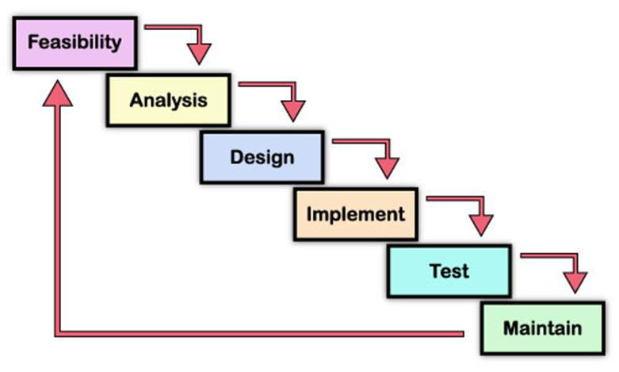

Figure 1: Waterfall Model

**3.2.1Planning**

The purpose of this phase is to determine the best solution and steps taken to develop the system. Planning involves the details planning for the timing of the working progress and types of technique will be taken next. Planning also involves that the methodology that will going to use for this project.

**3.2.2 Requirement Analysis**

The purpose of this phase is to build logical model of this system. In addition, this phase also needed to understand the applications, fact finding technique like document reviews, surveys, observations, and sampling must be made to identify application requirement, software requirement and hardware requirement. In this phase, what kind of data requirement and the functional requirement will been decide.

**3.3.1 Design**

This phase will produce draft of the system architecture and the prototype of the application that will satisfy all requirement analysis. At this phase the user interface and all necessary input and process will be identify. This phase also determine the application architecture, which is going to shows how to transform the logical design into basic system coding to generate the first prototype of the system. The result for this phase application interface and system design specification. For this project, the design will be created using the Java Net beans.

**3.3.2 Implementation**

During this implementation phase, the system will be constructed. All codes are generated inside this phase. At the end of this phase, system should running and most of the function for the system should be able to use. Based from the previous phase, from the prototype, the system will become the first version inside this phase.

**3.3.3 Testing**

This phase will evaluate or verify the system that was developed. This phase will have a simulation data which will simulate the true database for the system. This is to test the functionality of the system in comparing a capture data with a database. Beside, all the functionality that may cause errors or problems to the system must be specified inside this phase because, the final result of the system is a very high priority and important. However, the testing phase will only cover to overcome the problem statement and the system objectives.

**3.4 Software Requirement Specification**

**3.4.1**. Functional requirement

**3.4.1.1.** Software product features

**3.4.1.2** Login/Logout

To assure the security of the system, the user should sign before starting using the system and sign out after he finishes.

**3.4.1.3** Register

Users should create an account and their data are registered in the database.

**3.4.1.3.1** Send Email

Lecturers can send email to students to give some announcements regarding the exam.

**3.4.1.3.2** Upload

Lecturers can add questions and answers to the system

**3.4.1.3.3** View/ Student Report

This allows lecturers to view the students who fail or pass the exam. They can view according to grade A, B, C, D or F.

**3.4.1.3.4** Help

This enables users to see the information about the system and also the user manual.

**3.4.1.3.5** Select

This feature helps students to choose the subject and then proceed to answer the questions.

**3.4.2** Non-functional requirement

**3.4.2.2** Reliability

The system can update its content in real time. Therefore, changes such as addition, deletion or modification can be done immediately. This ensures that the content of the system is up-to-date, reliable and can be trusted. The system will also be able to produce all related output to queries.

**3.4.2.3** Availability

The system can operate 24 hours per week and 365 days a year. As long as the user not shut down the desktop. All the information will be keep in the database. Even though, the desktop is shut off information still exist in the database.

**3.4.2.4** Security and Safety

In order to avoid security and safety breach occur users need to login with username and password before they access the system. In database there have record the username and password. Only registered users can access the system and use it.

**3.4.2.5** Maintainability

The software is being developed by the Java NetBeans IDE 6.8. Thus the system can be update in the coding part to maintain the system.

**3.4.2.6** Portability

The system is being developed using Java programming language and MySQL. Before the system release to system needs to compile without any error before the system run. Therefore, the software will be able to run on any computer with NetBeans IDE 6.8 and MySQL.

**3.4.2.7** Performance

The system performance is very fast. The processed transactions and event response time is quick. So user can do the transaction any event without feel stress on waiting.

**3.4.2.8** Flexibility

System is working easily on the Intranet with the username and password of the user. The system has given the rights to the lecturers and the students to use the system with their username. The system can also work on other kind of technology with the little modification. System should be quite flexible to install and maintain.

**3.4.2.9** Efficiency

System should be efficient enough to meet all kinds of requirements as required by the lecturers and students. The system should not hang or lose its efficiency in any kind of worse conditions. It should provide the correct output in all manners.

**3.4.2.10** User Friendliness

System should be user friendly, so that any user can use and access the system with easiness.

**3.5.1 Use case diagram**

The unified modeling language used is use case diagram. A use case is a set of scenarios that describes an interaction between a user and a system. A use case diagram displays the relationship among actors and use cases. The two main components of a use case diagram are use cases and actors. The actors in our system are students and lecturers. The use case diagram is designed in the following figure.

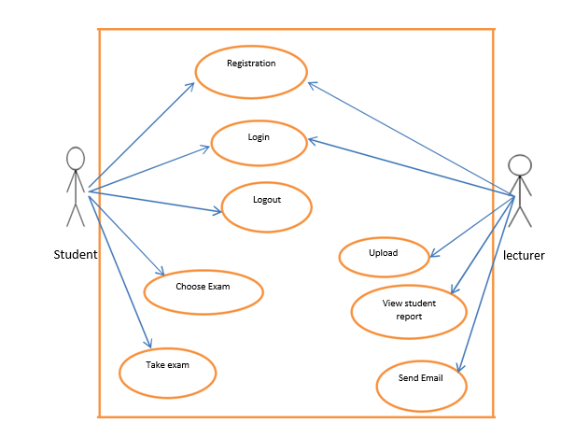

**3.5.2 System flow chart**

A system flowchart is a valuable presentation aid because it shows how my system major components fit together and interact. In effect, it serves as a system roadmap.

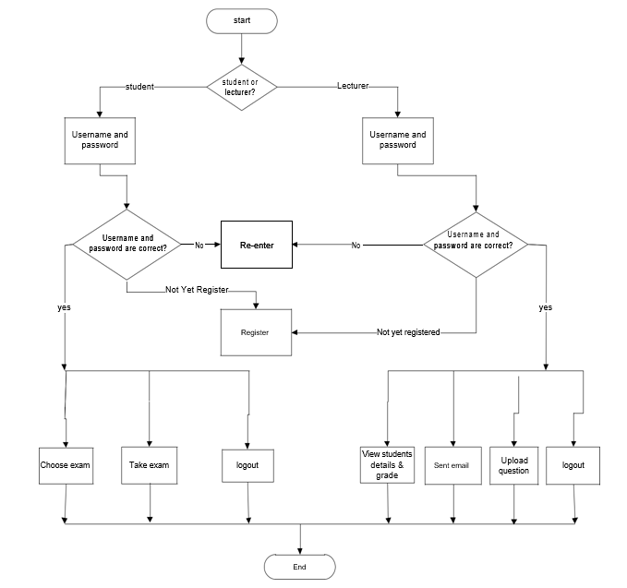

**3.5.3 Entity Relationship Diagram**

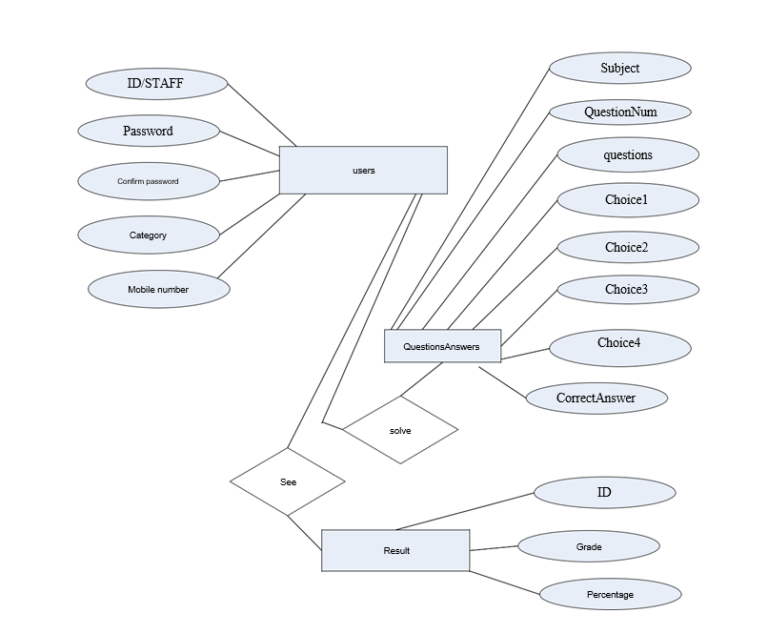

**3.5.4 Context Diagram**

The Context Diagram shows the system under consideration as a single high-level process and then shows the relationship that the system has with other external entities.

